**P4 – Create original graphic images to meet a defined user need**

**Introduction**

In this assignment, I will be creating graphic images on Adobe Photoshop CS6. Each picture will be different and I have chosen the following covers:

* A sporting event
* An concert event
* New movie release

Each of these images will be present and I will explaining the client needs, target audience, file format, intended use, constraints and user requirements for each one. In addition, I will explain how I made this picture by using the tools of it.

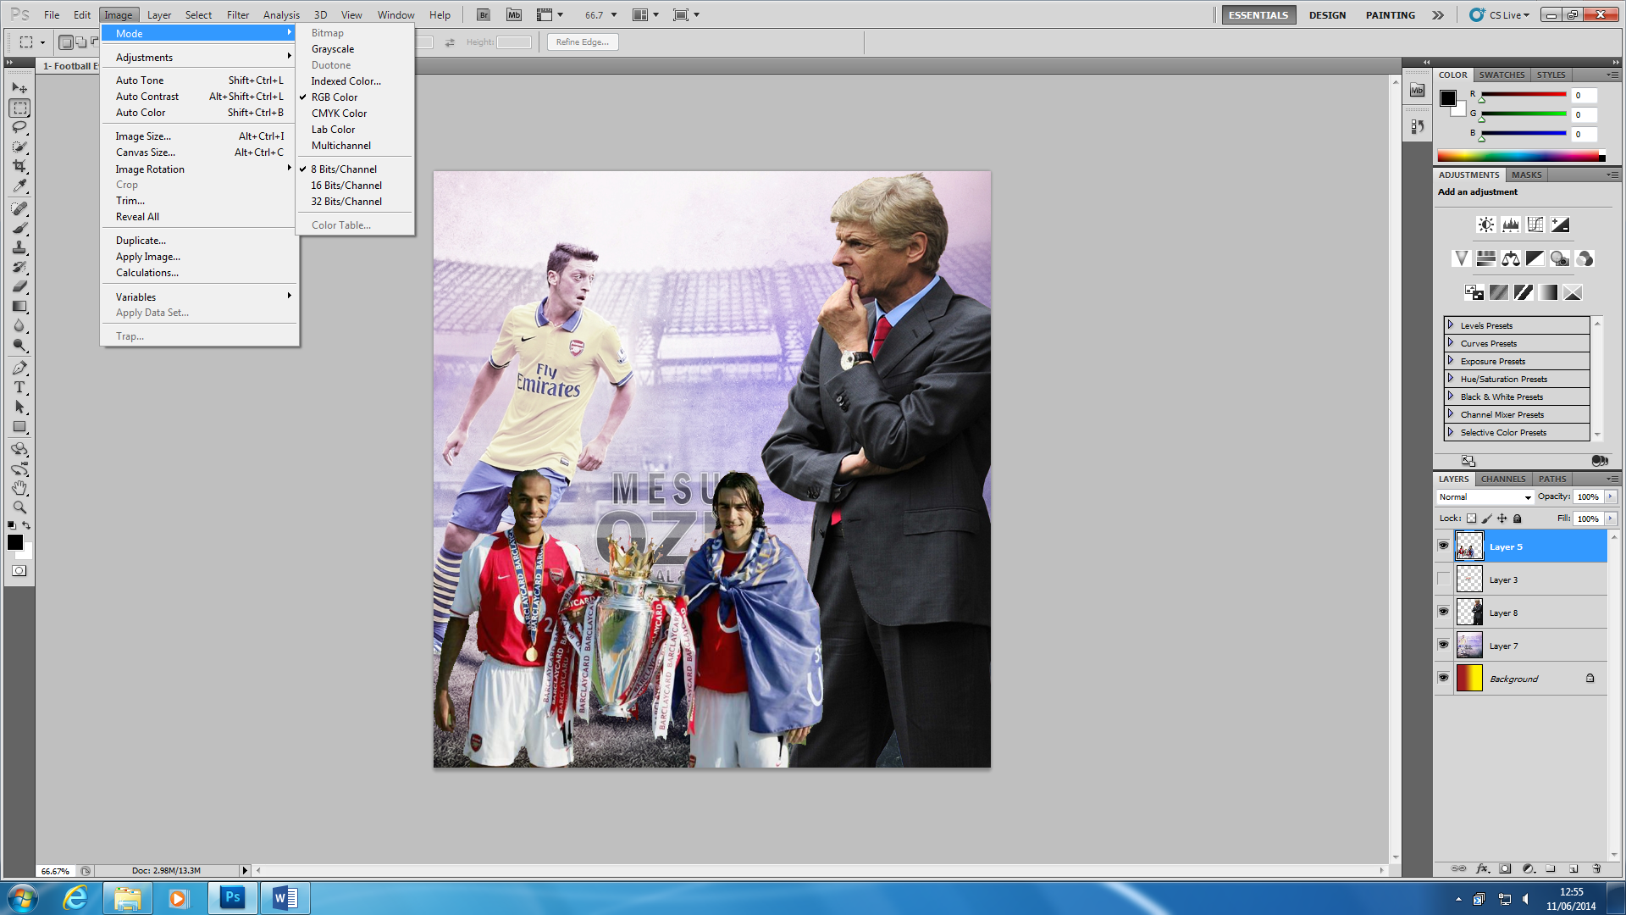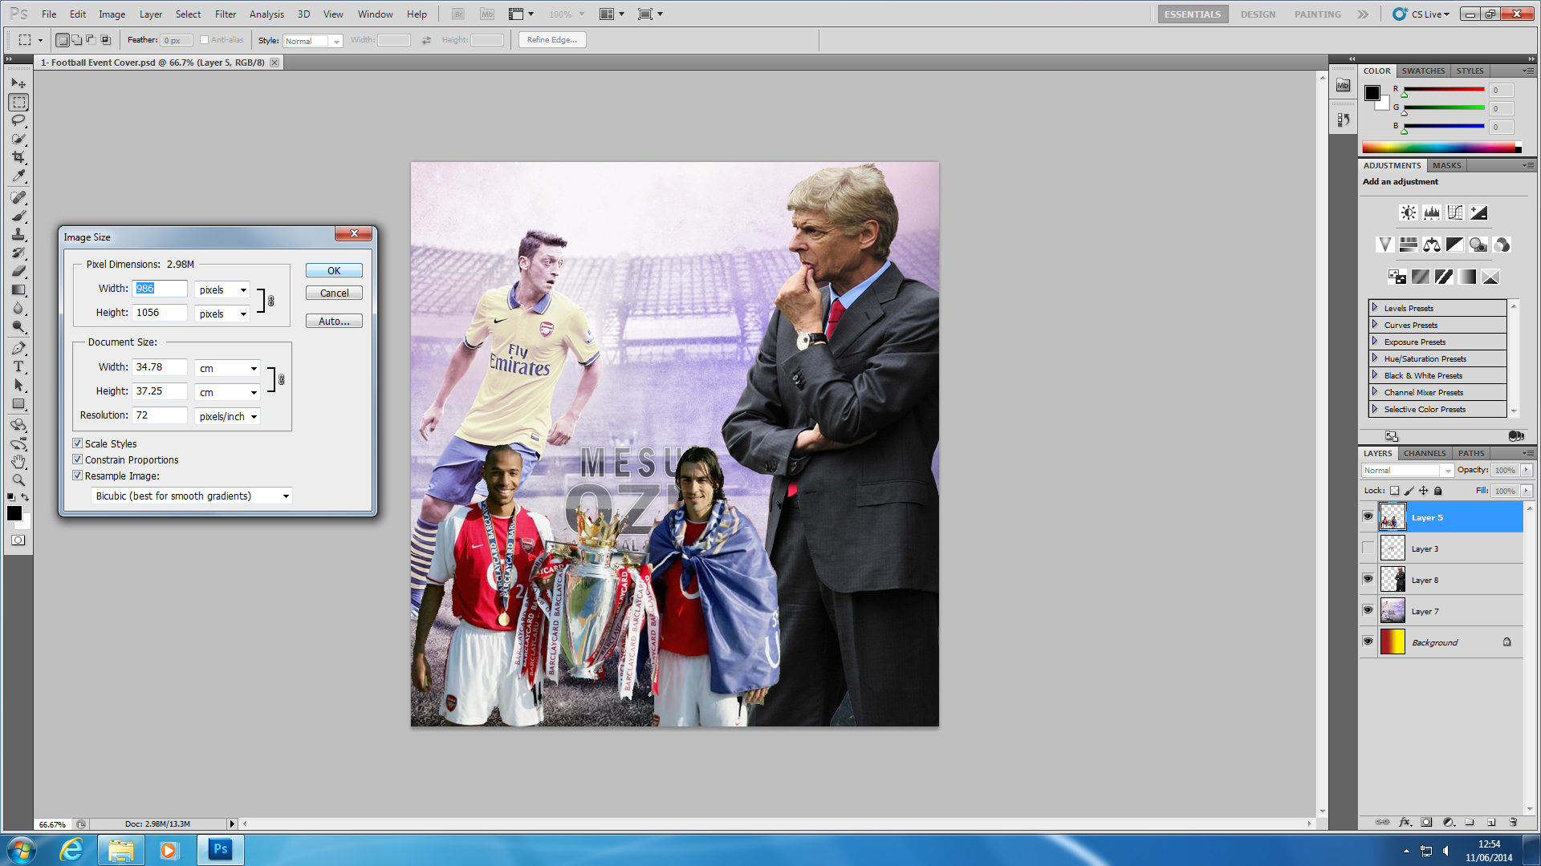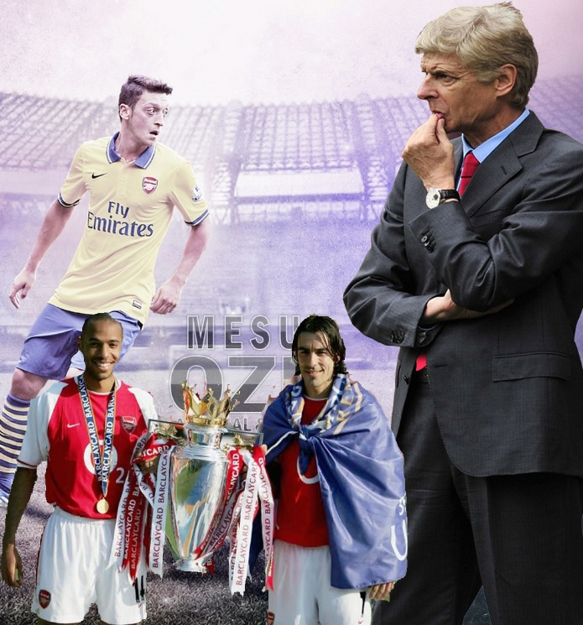

I have made this sporting event poster on Adobe Photoshop CS5.1. The **client needs** means is what satisfies the customer needs of any customer. This is a cover for a newspaper which is why it can fill any client’s need. The **target audience** for this poster is any age. It doesn’t need to be aimed at anyone nor any male or female. Any of them, it would be targeted at. **The file format** for this poster is Joint Photographic Experts Group (JPEG). Once I had made this on Adobe Photoshop, I saved it as a JPEG to enable me to use it on this document and it can become an image. The **image size** of this poster is 986 (width) by 1056 (height). I used this size as I could fit everything into this size. In addition, if this size was changed, it would look different and not the same for it. The **resolution** of this image is ‘72’, which is good enough for this poster. The

**A SPORTING EVENT**

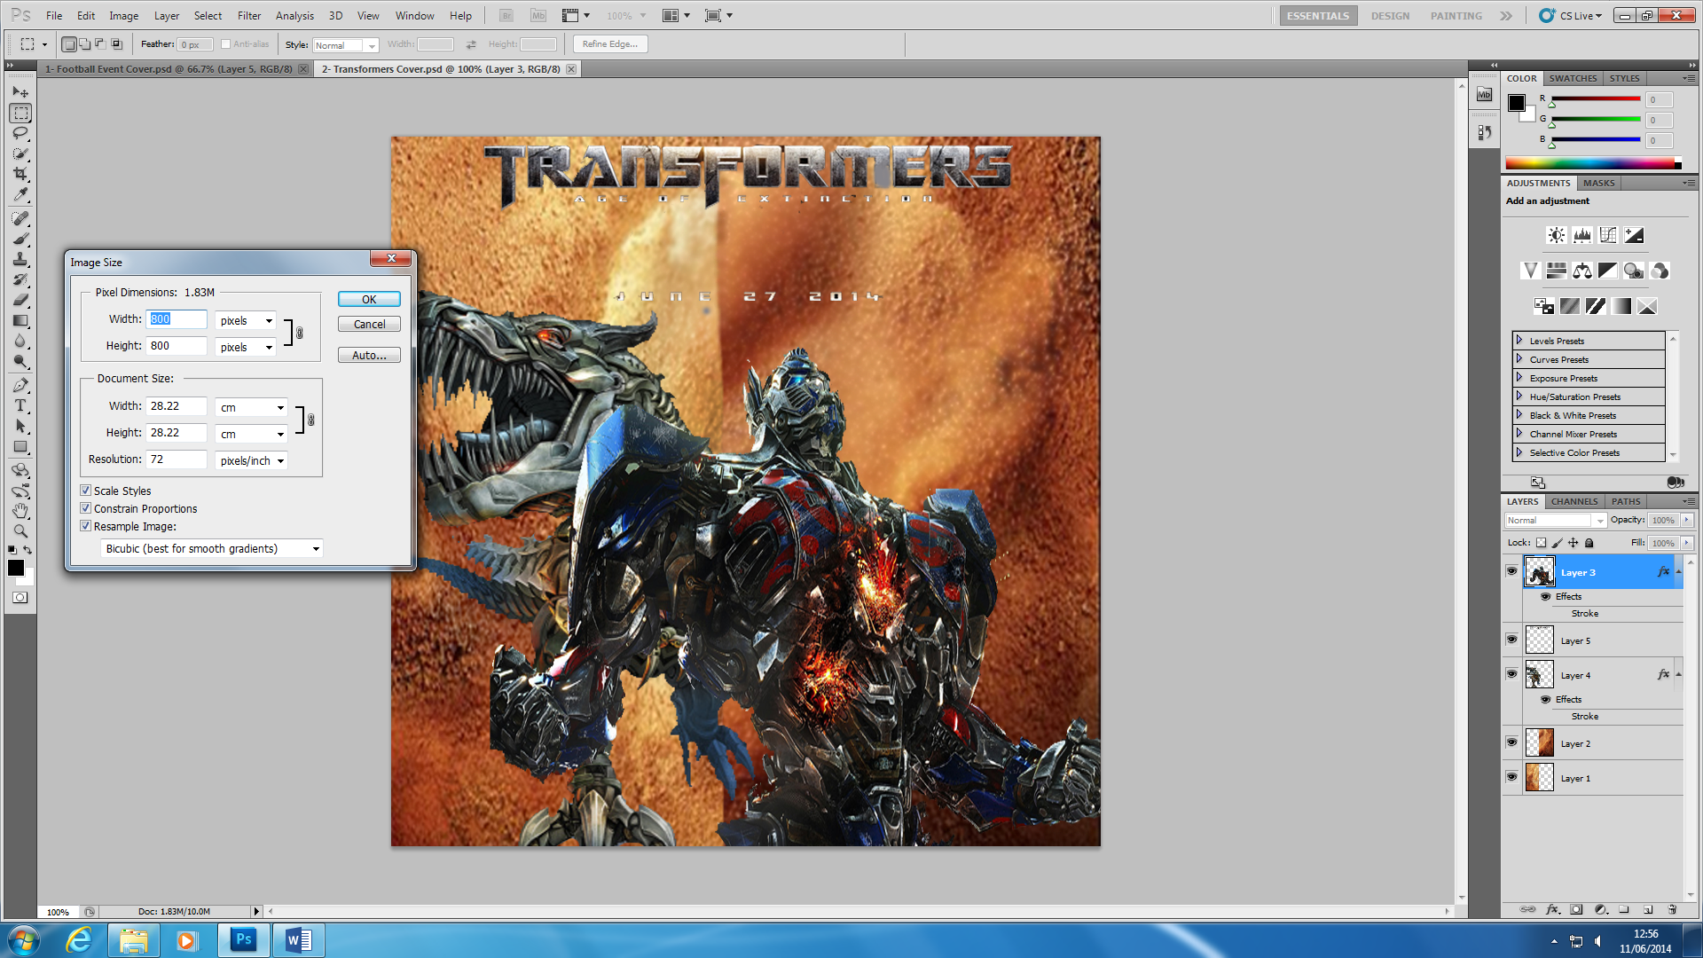

**A NEW MOVIE RELEASE**

I have made this ‘new movie release’ event poster on Adobe Photoshop CS5.1. The name of the movie is called Transformers – Age of the Extinctions. The **client needs** means is what satisfies the customer needs of any customer. This is a cover for a newspaper, which is why it can fill any client’s need. The **target audience** for this poster is at 12 and over. As they are 12 and over, they can watch the film, it could be male or female. **The file format** for this poster is Joint Photographic Experts Group (JPEG). Once I had made this on Adobe Photoshop, I saved it as a JPEG to enable me to use it on this document and it can become an image. The **image size** of this poster is 800 (width) by 800 (height). I used this size as I could fit everything into this size. In addition, if this size was changed, it would look different and not the same for it. The **resolution** of this image is ‘72’, which is good enough for this poster. The **colour mode** is 8 Bits.

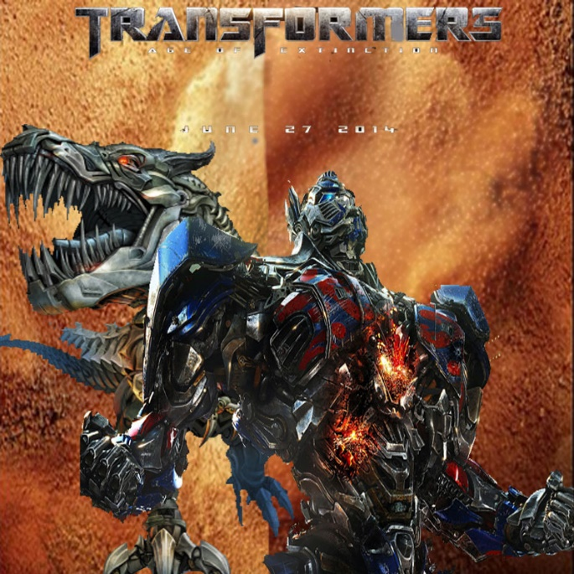

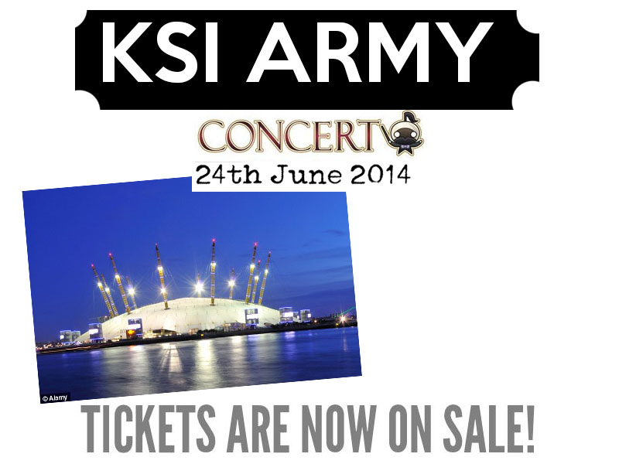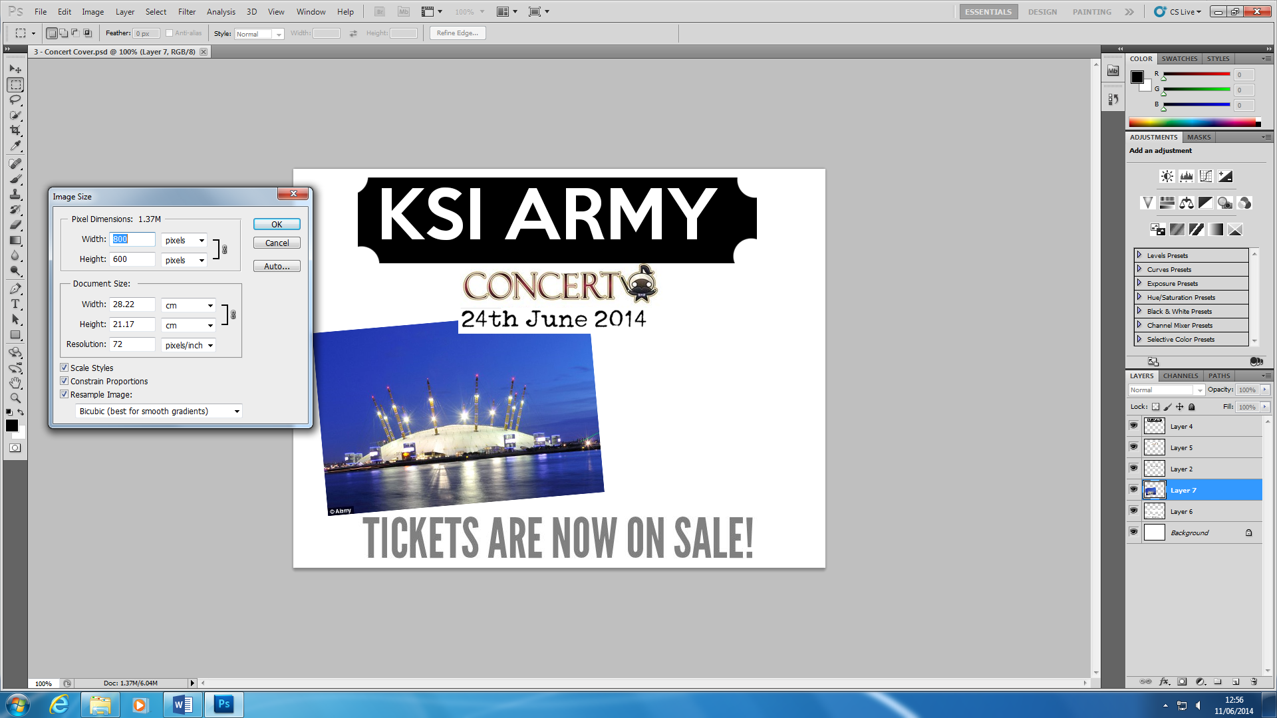

**CONCERT COVER**

I have made this concert cover poster on Adobe Photoshop CS5.1. The **client needs** means is what satisfies the customer needs of any customer. It is a concert so if they want to go, they can. This poster is to promote the KSI Army Concert. This is a cover for a newspaper, which is why it can fill any client’s need. The **target audience** for this poster is any age. It does not need to be aimed at anyone nor any male or female. It could be anyone that does not know who KSI is. Any of them, it would be targeted at. **The file format** for this poster is Joint Photographic Experts Group (JPEG). Once I had made this on Adobe Photoshop, I saved it as a JPEG to enable me to use it on this document and it can become an image. The **image size** of this poster is 600 (width) by 800 (height). I used this size as I could fit everything into this size. In addition, if this size was changed, it would look different and not the same for it. The **resolution** of this image is ‘72’, which is good enough for this poster. The **colour mode** is 8bits.

